Algebraic Operations (Session 1)

A Solving Equations

Example 1:
a) 4(t − 2) = 3 + 5(t − 3)
4t - 8 = 3 + 5t - 15
4t - 8 = 5t - 12
4t - 8 - 4t = 5t - 12 - 4t
-8 = t - 12
-8 + 12 = t - 12 + 12
4 = t

b) 5y − 4(y + 1) + 7(2y − 3) = 8
5y - 4y - 4 + 14y - 21 = 8
15y - 25 = 8
15y - 25 + 25 = 8 + 25
15y = 33
15y/15 = 33/15
y = 2.2

Example 2:
Transpose the following formula:
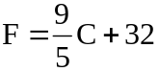 F - 32 = (9/5)C + 32 - 32
F - 32 = (9/5)C
(F - 32) / (9/5) = (9/5)C/(9/5)
C = (F - 32) / (9/5)
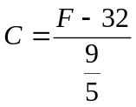

B Word Problems involving Linear Equations

Write an equation then solve it to answer the question.

1 Barbara has three times as many $2 coins as $1 coins and the total is $42. How many of each coin has she got?

2 One side of a square has a length of 3x + 5 metres and another side has a length of 5x - 3 metres. Find the length of one side of this square.

3 The total weight of a loaded car is 1188kg. This weight consists of that of the car, the luggage and the driver. The weight of the driver is double that of the luggage and the weight of the empty car is 30 times that of the luggage. What is the weight of the driver?

4 Kurt started with $38 then saved $9 per week until he had $110. How many weeks did he save for?

5 If a number is tripled and then added to twenty four, the answer is the same as multiplying the number by four. Find the number.

6 $57 is to be divided between two people so that one person gets twice as much as the other. How much does each get?

7 Two business partners invested a total of $6000 in their business. If one partner invested $600 more than the other, how much did each invest?

8 Two consecutive numbers are added together and their sum is 55. What are the numbers?

9 A number is doubled and then added on to the number one bigger than the original number. If the answer is 49, find the number.

10 A firm bought two new computers. One cost twice as much as the other. The total cost was $4770. Find the cost of the cheaper machine.

11 A grocer buys apples at 20 cents each. She finds that one dozen are bad. By selling the rest of them at 30 cents each, she makes a $5 profit. How many apples did she buy?

Answers
1 Six $1 coins and eighteen $2 coins
2 17 m 3 72 kg 4 8
5 24 6 $19 and $38 7 $2700, $3300
8 27 and 28 9 16 10 $1590
- 86

C Linear Equations in Two Unknowns

Example:

Solve for x and y
4x + 8y = 20
3x + 4y = 11

D Word Problems involving Simultaneous Equations

1 An adventure company taking tourists on rafting trips makes a fixed charge per group plus an additional charge per person.
One group of 6 paid $422
Another group of 9 paid $458
Find the fixed charge and the per person charge.
F = $350
P = $12

2 The cost of accessing the internet from the Solar Internet Company is a combination of a fixed charge per month plus a charge per Gigabyte of information which is downloaded.
A user who downloaded 4.53 Gigabytes one month paid $29.59. The next month this user downloaded 9.80 Gigabytes and paid $45.40. Calculate the fixed charge per month and the charge per Gigabyte.
F + 4.53G = 29.59
F + 9.8G = 45.4
5.27G = 15.81
G = $3

F + 13.59 = 29.59
F = $16

3 A shopkeeper buys two mixed consignments of boxes of fruit. One consignment has ten cases of apples and eight cases of pears and costs $79. The other consignment has six cases of apples and twelve cases of pears and costs $87. How much does each type of case of fruit cost?
10A + 8P = 79
6A + 12P = 87

30A + 24P = 237
12A + 24P = 174
----------------------
18A = 63
A = $3.50

10(3.5) + 8P = 79
35 + 8P = 79
8P = 44
P = $5.50

4 A customer buys two boxes of disks and 3 ink cartridges for $124. On another occasion this customer buys five boxes of disks and two ink cartridges. This time the cost is $112. Find the cost of a box of disks and an ink cartridge.

5 Three drinks and two bags of chips cost $6.30. Two drinks and five bags of chips cost $9.15. What are the prices of a drink and a bag of chips?

Answers
1 $350, $12 2 $16, $3 3 apples $3.50, pears $5.50
4 $8, $36 5 $1.20, $1.35

Algebraic Operations (Session 2)

E Linear Equations in Three Unknowns

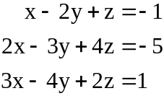Example:
Create matrix with columns: x coefficient, y coefficient, z coefficient, and answer, and one row for each equation.

1 -2 1 -1
2 -3 4 -5
3 -4 2 1

The goal is to achieve a matrix that looks like:

1 0 0 X
0 1 0 Y
0 0 1 Z

So we take a row, multiply it by a factor, and add it to a different row to cancel a variable to 0.

row1 * 2
= [1 -2 1 -1] * 2
= [2 -4 2 -2]

subtract the above from row 2:

1 -2 1 -1
2 -3 4 -5
3 -4 2 1

becomes

1 -2 1 -1
0 1 2 -3
3 -4 2 1

X is now eliminated from row 2.
Continue process:

subtract row1*3 from row3:

1 -2 1 -1
0 1 2 -3
0 2 -1 4

etc.

F Simultaneous equations with 3 variables

1 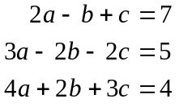 a = 1, b = -3, c = 3

2 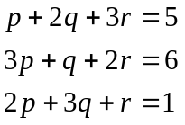 p = 1, q = -1, r = 2

3 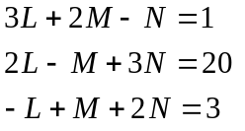 L = 3, M = -2, N = 4

4 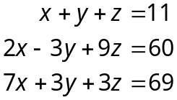 x = 9, y = -2, z = 4

5 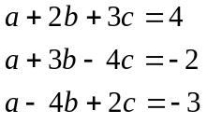 a = -1, b = 1, c = 1

6 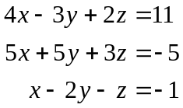 x = -1.3, y = -2.4, z = 4.5

Answers
1 1, -3, 2 2 1, -1, 2 3 3, -2, 4
4 9, -2, 4 5 -1, 1, 1 6 -1.3, -2.4, 4.5
G Further word problems

Equations must be written and working shown.

1 In order to sow a new lawn, a home handyperson needs to hire a rotary hoe, a roller and a seed spreader. Hire charges are as follows:
Rotary hoe $20 per hour
Roller $5 per hour
Seed spreader $4 per hour
The rotary hoe is required for twice as long as the roller and the seed spreader for half as long as the roller. The total costs $141.
How long was the seed spreader hired for?

2 The current i in a device depends on the voltage v according to
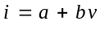
When the voltage is 1 volt, the current is 1 amp. When the voltage is 3 volts, then the current is 7 amps. Calculate a and b.

3 The Gilbert family went on a sightseeing trip and paid $120 for 4 adults and 6 children. The Smithson family of 2 adults and 4 children went on the same trip and paid $70. Find the cost of an adult’s and a child’s ticket.

4 Club members sold raffle tickets to raise money for a tournament.
Rebecca sold twice as many tickets as Sarah. Edmond sold 15 more tickets than Jim and Jim sold 36 more tickets than Sarah. How many tickets did Rebecca sell if the four club members sold 777 tickets altogether?

5 Tickets to a show are cheaper for students. If a group of 21 people, 4 of whom were students, paid $194, and another group of 16, 5 of whom were students paid $140, how much were the tickets?

Answers
1 1.5 hours 2 -2, 3 3 Adult $15, Child $10
4 276 5 $10 and $6

